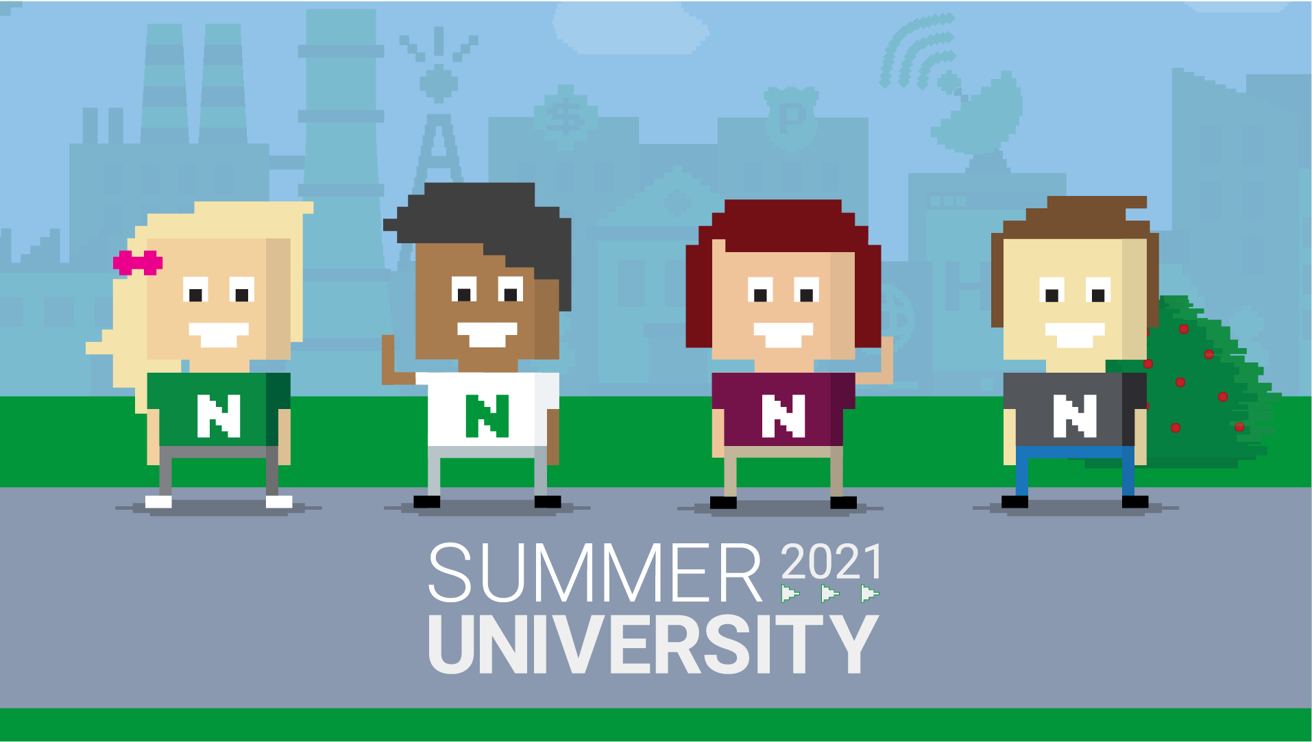

Don’t miss out! Join **Nortal Summer University 2021** and kick-start your IT career as a **JAVA developer!**

Nortal is on the lookout for**IT enthusiasts** from all walks of life to join **Summer University**, an exceptional program for bright talents in **Lithuania**. Participants **will be employed* and trained with the industry’s best**, perfecting skills through personal **mentorship** and rewarding work on **real-world projects**.

**\*We offer unlimited employment contracts for all selected participants.**

**Can anyone apply?**

Anyone interested in the role we are offering,**regardless of education or career background**, is encouraged to apply. Our aim is to find **savvy team players** with a positive mindset, then teach them the technical skills necessary for the role.

**What can you expect?**

* **Salary** from day one
* **IT training**
* Work on real, **ongoing projects**
* Personal **mentorship**
* **Flexible** working hours
* **Solid benefit package**

**When?**

* Sign-up till 04.18
* Info Day 04.08 at 3PM
* Test Assignment 04.19 – 04.25
* Virtual Meetings 05.10 – 05.13
* Work starts! May/June

**Want to know more?**

We encourage to attend our virtual Information Day on **April 8th. at 3PM.** Register for the event: <https://fb.me/e/6jTFaQmN0>

Go beyond traditional education and start your career with Nortal! Read more & apply: <https://nortal.com/careers/summeruniversity/>